Differential Backup

Definition
# Source: AI Source: Provided by: [Data Path: Persons Table -> ID Column: 1, Name_En Column: Motasem Essam] -> From: [Chatgpt (GPT‑5 Mini)] on [12/10/2025]
A Differential Backup is a type of backup where all data that has changed since the last full backup is saved. Unlike incremental backups, it does not depend on previous differential backups, only on the last full backup.

Key Idea
# Source: AI Source: Provided by: [Data Path: Persons Table -> ID Column: 1, Name_En Column: Motasem Essam] -> From: [Chatgpt (GPT‑5 Mini)] on [12/10/2025]
Differential backups strike a balance between full and incremental backups by reducing backup time compared to full backups while simplifying recovery compared to incremental backups.

How It Works
# Source: AI Source: Provided by: [Data Path: Persons Table -> ID Column: 1, Name_En Column: Motasem Essam] -> From: [Chatgpt (GPT‑5 Mini)] on [12/10/2025]
- Perform a full backup as the initial step.
- Track all changes since that full backup.
- Back up all modified or new data since the full backup.
- Repeat this process at scheduled intervals (e.g., daily) until the next full backup.

Example
# Source: AI Source: Provided by: [Data Path: Persons Table -> ID Column: 1, Name_En Column: Motasem Essam] -> From: [Chatgpt (GPT‑5 Mini)] on [12/10/2025]
- A full backup of a database is done on Sunday.
- On Monday, all changes since Sunday are backed up (Monday differential backup).
- On Tuesday, all changes since Sunday are backed up again (Tuesday differential backup), and so on.

Advantages
# Source: AI Source: Provided by: [Data Path: Persons Table -> ID Column: 1, Name_En Column: Motasem Essam] -> From: [Chatgpt (GPT‑5 Mini)] on [12/10/2025]
- Faster than full backups because only changed data is copied.
- Simpler recovery than incremental backups: Only the last full backup and the latest differential backup are needed.
- Reduces risk of data loss compared to incremental backups if one differential backup fails.

Disadvantages
# Source: AI Source: Provided by: [Data Path: Persons Table -> ID Column: 1, Name_En Column: Motasem Essam] -> From: [Chatgpt (GPT‑5 Mini)] on [12/10/2025]
- Backup size grows over time until the next full backup.
- Slower than incremental backups as more data accumulates.
- Requires regular full backups to prevent differential backups from becoming too large.

Differential Backup VS Incremental Backup

1. Differential Backup
# Source: AI Source: Provided by: [Data Path: Persons Table -> ID Column: 1, Name_En Column: Motasem Essam] -> From: [Chatgpt (GPT‑5 Mini)] on [12/10/2025]
- Each backup saves all changes since the last full backup.
- Example:
  - Sunday: Full Backup
  - Monday: Backup all files changed since Sunday → Differential Backup
  - Tuesday: Backup all files changed since Sunday → New Differential Backup
- Restore: Only need the last full backup + the latest differential backup.
- Advantage: Restoration is fast and simple.
- Disadvantage: Each day’s backup gets bigger because it includes all changes since Sunday.

2. Incremental Backup
# Source: AI Source: Provided by: [Data Path: Persons Table -> ID Column: 1, Name_En Column: Motasem Essam] -> From: [Chatgpt (GPT‑5 Mini)] on [12/10/2025]
- Each backup saves only the changes since the last backup (full or incremental).
- Example:
  - Sunday: Full Backup
  - Monday: Backup files changed since Sunday → Incremental Backup
  - Tuesday: Backup files changed since Monday → New Incremental Backup
- Restore: Need the last full backup + all incremental backups since then.
- Advantage: Backups are smaller and faster.
- Disadvantage: Restoration is slower and more complex, and if any incremental backup is missing, recovery can fail.

Easy Way to Remember
# Source: AI Source: Provided by: [Data Path: Persons Table -> ID Column: 1, Name_En Column: Motasem Essam] -> From: [Chatgpt (GPT‑5 Mini)] on [12/10/2025]
- Differential: “Changes since full backup” → Fast to restore, bigger backup size.
- Incremental: “Changes since last backup” → Small backup size, slower and more sensitive to missing backups.

Summary
# Source: AI Source: Provided by: [Data Path: Persons Table -> ID Column: 1, Name_En Column: Motasem Essam] -> From: [Chatgpt (GPT‑5 Mini)] on [12/10/2025]
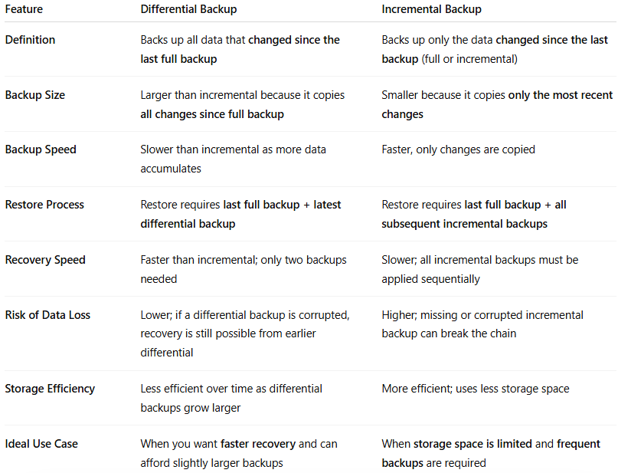
Feature | Differential Backup | Incremental Backup
Definition | Backs up all data that changed since the last full backup | Backs up only the data changed since the last backup (full or incremental)
Backup Size | Larger than incremental because it copies all changes since full backup | Smaller because it copies only the most recent changes
Backup Speed | Slower than incremental as more data accumulates | Faster, only changes are copied
Restore Process | Restore requires last full backup + latest differential backup | Restore requires last full backup + all subsequent incremental backups
Recovery Speed | Faster than incremental; only two backups needed | Slower; all incremental backups must be applied sequentially
Risk of Data Loss | Lower; if a differential backup is corrupted, recovery is still possible from earlier differential | Higher; missing or corrupted incremental backup can break the chain
Storage Efficiency | Less efficient over time as differential backups grow larger | More efficient; uses less storage space
Ideal Use Case | When you want faster recovery and can afford slightly larger backups | When storage space is limited and frequent backups are required

